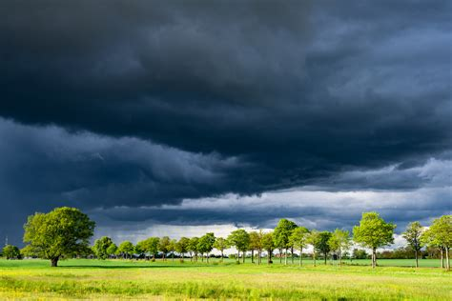

+ DEAR FRIENDS,

AT THIS EASTER SEASON OF 2025, SPRING SHINES BRIGHTER THAN EVER,

PERHAPS PRECISELY BECAUSE THE STORM CLOUDS OF OUR TIME ARE

LOOMING SO DARK, SO HEAVY OVER US.

PEOPLE ASK ME AGAIN AND AGAIN: “WHAT CAN WE DO IN THIS SITUATION?”

WHAT I MYSELF AM TRYING TO DO IS TWOFOLD: TO GRATEFULLY ENJOY THE

GIFT OF EVERYTHING THAT’S NEWLY GROWING IN NATURE AND IN SOCIETY;

AND TO CONTRIBUTE TO SPRINGLIKE NEW BEGINNINGS, WHEREVER

THE OPPORTUNITY ARISES – INDEED IT ARISES ALL AROUND US

IF ONLY WE ARE AWAKE.

AN EXAMPLE: A NEW SENSE OF RESPONSIBILITY FOR THE ENVIRONMENT IS

EMERGING – A FACT THAT MAY MAKE OUR SURVIVAL POSSIBLE.

THIS CERTAINLY IS CAUSE FOR JOY – AND FOR ACTING RESPONSIBLY –

SAY, BY TURNING OFF ELECTRIC LIGHTS WHERE THEY ARE NOT NEEDED.

EVEN SIMPLE STEPS LIKE THIS CAN GO A LONG WAY TO HELP US

NOT TO TURN INTO SLEEPWALKERS.

SO MUCH DEPENDS ON WAKING UP: WHAT FACILITATES THE SHAMEFUL

CRIMES OF THE FEW IS THE EQUALLY SHAMEFUL SLEEPINESS OF THE MANY.

MY BIBLE TEXT FOR EASTER 2025 IS THIS ONE:

“AWAKE, YOU WHO SLEEP, AND ARISE FROM THE DEAD!” (EPH.5:14)

OUR WAKING UP TO THE MANY OPPORTUNITIES WE HAVE BEEN GIVEN

TO HELP BUILD A BETTER FUTURE, THAT IS – HERE AND NOW –

A “RESURRECTION FROM THE DEAD”.

WAKING UP IS WHAT I WISH YOU AND ALL OF US,

YOUR BROTHER DAVID